|  |  |
| --- | --- |
| **Problem Statement Assignment 1 session 1** | **Solutions** |
| **1.Say True or False for the below statements:** |  |
| • Prescriptive Analytics used to predict the future outcomes? | **No-** prescriptive analysis provides recommendations for actions to be taken for diagnosed problem. It’s the predictive analysis which predict future outcomes based on given historical data. |
| • Base R packages installed automatically? | **Yes-** with R package downloaded from CRAN repository base R packages gets installed automatically. |
| **2. What is Recycling of elements in a vector?** | Vectors can use simple arithmetic expressions (+, -, *, /) to perform basic operations. First look at addition, then discuss a caveat of vector arithmetic’s.  > c(1,2,3) + c(99,98,97)  [1] 100 100 100  > c(1,2,3) + c(4,5,6)  [1] 5 7 9  > c(1,2,3) - c(1,1,1)  [1] 0 1 2  But what would happen if all the vectors weren't of the same length?  Instead of erroring out, R performs *recycling*.  **Thus, *Recycling* occurs when vector arithmetic is performed on multiple vectors of different sizes. R takes the shorter vector and repeats them until it becomes long enough to match the longer one.**  **Lets see an eg below** |
| **3. Give an example of recycling of elements.** | > c(1,2,3,4,5,6) + c(1,3)  [1] 2 4 3 7 6 9  It can be seen, that the c(1,3) vector repeated itself to form c(1,3,1,3,1,3) so that it could successfully match the previous term.  If the shorter vector is not a vector of the longer one, then a warning message appears, but the operation still takes place.  R  > c(1,2,3,4,5) + c(1,3)  [1] 2 5 4 7 6  Warning message:  c(1, 2, 3, 4, 5) + c(1, 3) :  longer object length is not a multiple of shorter object length |

Recycling of element- vector repeated itself to form c(3,2,,3,2,3,2) so that it could successfully match the previous term.

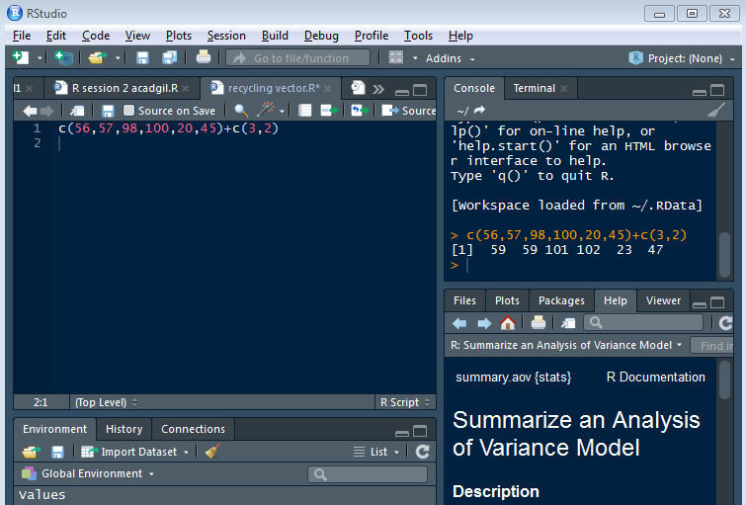

Shorter vector is not a vector of the longer one, then a warning message appears, but the operation still takes place.

